Support Personnel Accountability

Report Card (SPARC)

2018–19 Instructions

Submission deadline is March 15, 2019, at 5:00 p.m.

Late submissions are not accepted.
The SPARC requirements, student outcome lists, and helpful hints needed to complete your SPARC are in these instructions, which are also posted online. Use them to complete your SPARC.
The SPARC process has four steps:
- Setting up a new or accessing an existing account.
- Complete your SPARC.
- Submit your SPARC for review.
- Review by the California Department of Education.

Setting up a new or accessing an existing account.
Your school must have a SPARC account to participate. Each school is limited to one account.
If you do not have an account and would like to participate, complete the Create Your Own SPARC Signup form. You may also access this form from the SPARC Online homepage.
Note: When establishing a new account, your official SPARC contact for your account must be a permanent school site employee with a school or district domain email address. Your official contact cannot be a student intern or other non-permanent staff.

Complete your SPARC.
Before typing your content into the SPARC Online application, use the template at the end of this document to organize and peer review your information. Once you are satisfied with what you have written, cut and paste your information into the SPARC Online application. The template is also posted on the SPARC Instructions webpage as well as on the Welcome to SPARC Online page inside your account.

Submit your SPARC for review.
Approvals: While your SPARC does not require digital signatures, it does require approval from specific individuals.
Inside your account is an Approvals section. Type in the names of the people who have written, edited, or confirmed the information and/or approved the submission.
This list must include all members of the Student Support Team, one parent, one student representative, the Principal, and the Superintendent (or CEO).
Important: Inclusion of a person’s name in the Approvals section signifies she or he participated in, approved of, and/or granted permission to post your SPARC online.
Submission: Submit your completed SPARC electronically via the SPARC Online Application. When you select “submit”, your SPARC will be forwarded for review and you will be redirected to the survey. You must complete the survey to complete the submission process.
When you download a copy of your SPARC after submitting it for review, the word “Draft” will appear on the bottom of page two. This will change to the official SPARC Seal once your SPARC passes the review.
Questions or notifications about your SPARC will be emailed to your official school contact person (named on your signup form). This person must be a permanent, full-time school employee. Your SPARC may be developed by a graduate student intern but your intern cannot be the official contact.

Review by the California Department of Education (CDE).
The CDE will review SPARCs for adherence to the content and formatting requirements as described in these instructions. Schools are solely responsible for the accuracy, timeliness, and completeness of the information and data contained in their SPARC. Approval of a SPARC is contingent on meeting all content and format requirements.
The CDE reviewers will check to see if all the requirements have been met.
Thoroughly review the Instructions, use the Template, and Submission Review Checklist to ensure your SPARC will be approved.
Important: Your student outcome data and your outcome narratives must match.
The SPARC Template is included with these instructions and will help you meet the character count limits, spot typos, and grammatical errors. Using the template will keep you from losing your data in case technical glitches occur when typing content directly into the online application. The template is also posted on the SPARC Online Instructions page.
The SPARC Submission Review Checklist is also included with these instructions and will help ensure you have included all required content for each section of the SPARC. The checklist is also inside your account.
Your SPARC is a professional document that will be available to a world-wide audience. SPARCs with errors cannot be posted. Here are some common errors to avoid:
- Missing content. Leaving out required content.
- Writing mistakes (spelling, grammar, punctuation, capitalization, verb agreement, possessives, plurals, sentence structure, and word choice [using “council” when you mean “counsel”]).
- Inconsistent acronyms or initialisms (referring to your school by its official name then using a variety of shortened versions or initialisms).
- Using symbols like ampersands (&) and ellipsis (…).
Approved SPARCs receive the SPARC Seal and a SPARC Certificate of Participation and are posted on the CDE’s California Career Resource Network’s website.

Required Content
Below are the detailed content requirements for each of the five SPARC sections:
- Principal’s Message
- Career and College Readiness Student Outcomes
- 21st Century Skills
- School Site Programs and Community Partnerships
- Student Support Team
The following information is inside your online application in their respective sections so you can refer to them while completing your SPARC.

Principal’s Message
In this section, your narrative should describe the role of the school’s student support system and team in promoting student career and college readiness.

Required Elements
- Must include a statement on the school’s efforts to support all students in becoming career and college ready.
- Must include a statement on making/keeping your school environment safe with a climate conducive to career and college readiness success.
- Must include one or two career and college ready goals the Student Support Team (SST) hopes to achieve in next year.
- Must include a statement regarding the alignment of your SPARC to your school’s Local Control Accountability Plan or Single Plan for Student Achievement. (This requirement does not apply to adult education programs, private schools, or charter schools.)

Helpful Hints
Review the SPARC examples included at the end of this document. They are also posted on the SPARC Online Instructions webpage.
- The SPARC provides an opportunity to highlight the leadership of your SST in helping students become career and college ready. The Principal’s Message should highlight the work of the SST in meeting the school’s career and college readiness work and goals.
- Your school’s School Accountability Report Card (SARC) may contain useful content for this section. You can find your school’s SARC at the CDE webpage, “Find a School Report Card”.

Career and College Readiness Student Outcomes
In this section, you will provide evidence documenting the impact your SST is having in helping students develop career and college readiness knowledge and skills.
Definition of Student Outcome: Student Outcomes are measurements of student achievement. Outcomes must indicate the end result of student work: graduation, activities or workshops completed, assessment results, certifications earned, new knowledge acquired as indicated by assessments taken, etc. Participation in a course or program is not a student outcome. “Results” mean the knowledge, skills, or abilities a student acquired.
When selecting your student outcomes, keep in mind:
Career readiness outcomes indicate a student is gaining the skills and knowledge necessary to proceed to the next step on a chosen career path, whether that path is postsecondary career-related coursework, industry certification, or entry into the workforce. Employability skills and technical, job-specific skills related to a specific career pathway are essential in any career area.
College readiness outcomes indicate a student is gaining the skills and knowledge necessary to succeed in credit-bearing courses in college. “Success” is defined as completing entry-level courses at a level of understanding and proficiency that prepares the student for subsequent courses.

Required Elements

Student Outcomes Introduction
Write a general narrative describing the importance of student outcomes in evaluating program effectiveness. Reference the two outcomes you select in the career and college readiness categories.

Student Outcome Selection
Select an outcome from the dropdown menu for each of the two categories: Career Readiness and College Readiness. You must select one outcome for each category.
Each outcome has a narrative textbox where you will describe and explain the outcome you selected.
- In each outcome narrative, you must include the data that describes your chart and matches the outcome you selected.
- Explain the SST’s role in obtaining the outcome results. To help show the connection between SST efforts and the outcome results, use language like “Members of the SST supervised, provided technical assistance, arranged for resource allocation, monitored, taught/led groups, coordinated, contributed, etc.”
- Select the type of chart you want (bar or pie), type in your labels (Year, Grade, Other) and data in the appropriate textboxes, then select “preview chart” to review your chart.

Helpful Hints
Review the SPARC examples included at the end of this document. They are also posted on the SPARC Online Instructions webpage.

Working with Charts
You can compare your data in a variety of ways such as
- year-to-year (2017 to 2018),
- a series of years (2016, 2017, 2018),
- across grades in one year (8th, 9th, 10th grades in 2018),
- or any comparison that makes sense for the data you plan to use.
The following examples show how the data you enter is converted into the chart that appears on your SPARC.
Example 1.
The outcome is completing a college options project and the data show a three-year comparison using a percentage of students:
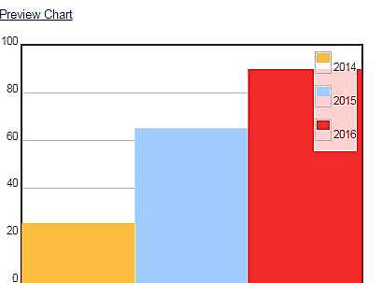
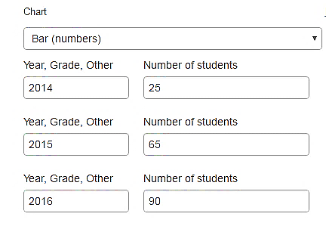
You enter your data SPARC generates your chart

In Example 1, the years (2014, 2015, and 2016) become your chart’s legend to identify your data. Your data becomes the bars in the chart.

Example 2.
The outcome is the number of students that can clearly describe their postsecondary goals:
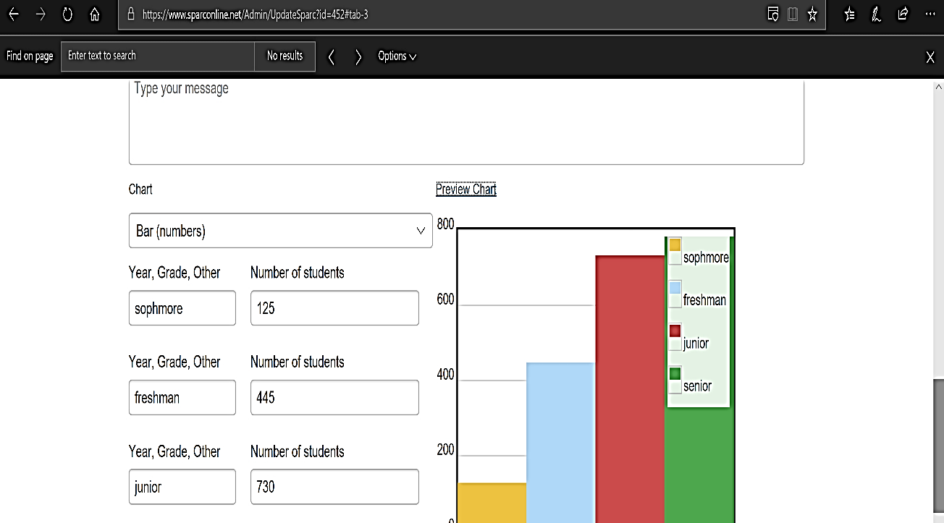
You enter your data SPARC generates your chart
In Example 2, students’ grade levels become your chart’s legend to identify your data. Your data becomes the bars in your chart.

Example 3.
The outcome is workplace habits practiced and documented and the supporting data are the number of students participating in school activities that build workplace habits:
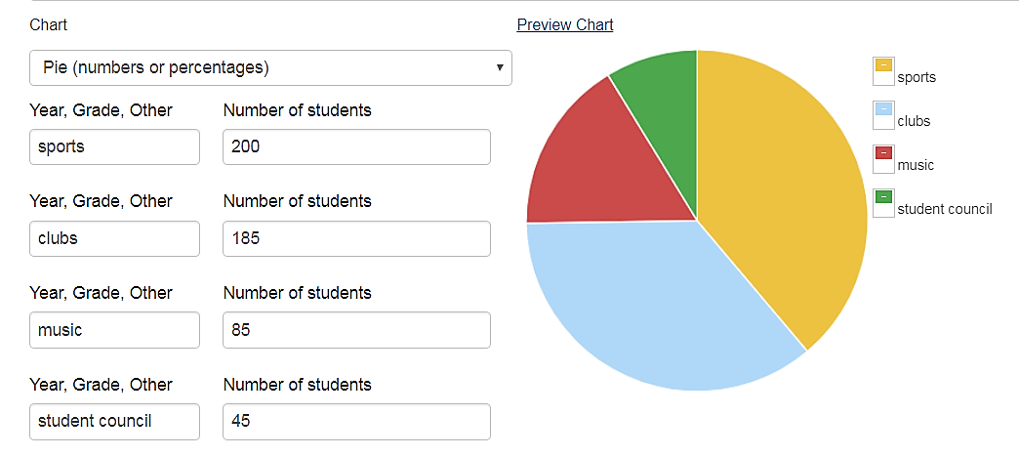
You enter your data SPARC Online generates the chart
In Example 3, the activities (Sports, Clubs, Music, and Student Council) become your pie’s legend to identify your data. Your data becomes the pie pieces.

Student Outcomes Dropdown Menu
You will choose one outcome from the Career Readiness dropdown menu and one outcome from the College Readiness dropdown menu. Here are the dropdown menus:

Career Readiness Options
- Academy Graduation
- ASVAB Career Exploration Program Completed
- California Career Center Assignment Completed
- California CareerZone Assignment Completed
- Career Action Plan/Postsecondary Plan Developed
- Career Exploration Activity/Module Completed
- Career Options can be Clearly Described
- Career Pathway Completed
- Career Technical Education/Industry Certificate Earned
- Career Technical Education Course(s) Completed
- Career Technical Education Program of Study Completed
- Career Technical Student Organization (CTSO), Active Involvement
- Career-related Certificate Earned
- Computer-assisted Career Planning Program Assignment Completed
- Financial Literacy Activities/Programs Completed
- High School Plan Developed
- Internship Completed
- Job Search Skills Acquired
- Middle School Plan Developed
- Occupational/Career Goal can be Clearly Described
- Postsecondary Goal can be Clearly Described
- Skill Certificates Earned
- Work-ready Certificate Earned
- Workplace Habits Practiced and Documented

College Readiness Options
- Achieving Academically at Grade Level
- A-G Sequence of Courses Completed
- ACT Results
- AVID Program Completed
- California Public College Options can be Clearly Described
- College Acceptance
- College Admission Requirements Completed
- College Application Account Established
- College Education for Career Goals can be Clearly Described
- College Enrollment
- College Goal/Major can be Clearly Described
- Community College Course Completed
- EAP Results
- FAFSA Submitted
- Homework and Study Skills Acquired/Practiced
- Honor Roll Recognition
- Online Course Completed
- PSAT National Merit Scholarship Qualifiers
- SAT Results
- Scored 3 or Better on Advanced Placement Exams
- Study and/or Test Taking Skills Acquired/Demonstrated

FAFSA and Financial Literacy Tip
“FAFSA Submitted” is a College Readiness indicator. It is not a Career Readiness financial literacy indicator. Financial literacy is defined as “the ability to use knowledge and skills to manage financial resources effectively for a lifetime of financial well-being.” Students completing a California CareerZone Make Money Choices or similar activity would qualify as a financial literacy indicator.

Elementary School Tips
Elementary school teams are encouraged to participate in the SPARC process so they, too, can document the career and college readiness work they are doing. The following is a list of outcomes that elementary school SSTs may find more relevant to their grade levels. However, elementary school SSTs can choose any outcome indicator.

Elementary School Career Readiness Outcomes
- California Career Center Assignment Completed
- California CareerZone Assignment Completed
- Career Exploration Activity/Module Completed
- Career Options can be Clearly Described
- Financial Literacy Activities/Programs Completed
- Middle and High School Plan Developed
- Occupational/Career Goal can be Clearly Described
- Postsecondary Goal can be Clearly Described
- Workplace Habits Practiced and Documented

Elementary School College Readiness Outcomes
- Achieving Academically at Grade Level
- California Public College Options can be Clearly Described
- Homework and Study Skills Acquired/Practiced
- Honor Roll Recognition
- Study and/or Test Taking Skills Acquired/Demonstrated

21st Century Skills
This section provides an opportunity to discuss the ways your school teaches students 21st Century Skills. Twenty-first Century Skills are identified as being necessary for success in the modern world of work.

Required Elements
Write a narrative describing activities used and the 21st Century Skills developed (see Helpful Hints for examples of 21st Century Skills). Be sure to describe the SST contribution in achieving those outcomes.
To help show the connection between SST efforts and the outcome results, use language like “Members of the SST supervised, provided technical assistance, arranged for resource allocation, monitored, taught/led groups, coordinated, contributed, etc.”

Additional Achievements
Use this space to briefly describe up to three additional career and college readiness related achievements not included elsewhere in your SPARC.

Helpful Hints:
Review the SPARC examples posted on the SPARC Online Instructions webpage.

Examples of 21st Century Skills
- Collaboration
- Communication
- Creativity and Innovation
- Critical Thinking and Problem Solving
- Ethics and Legal Responsibilities
- Information and Media Literacy
- Leadership
- Responsibility and Flexibility
- Self-management
- Teamwork
While there is no definitive list of 21st Century Skills, you may wish to refer to the following resources for more information:
- Skills and Qualities for the 21st Century World of Work
- California Standards for Career Ready Practice

School Site Programs and Community Partnerships
This section asks you to identify your school site programs and community partnerships. These programs and partnerships should reflect an active relationship in funding, organizing, monitoring, collaborating, and/or referrals with your student support system and school.

School Site Programs
These are onsite programs and services that support student career and college readiness. Examples of school site programs include curricular resources, leadership/personal skills opportunities, student organizations, career centers, peer programs, etc.

Community Partnerships
These are external agencies that provide their talents and opportunities to your students. Resources provided by community partners may include financial support, internships, referrals, mentoring, etc. Examples include chambers of commerce, local colleges, businesses, and other community-based organizations.

Required Elements
Must include a narrative explaining the importance of school site programs and community partnerships in helping your students become career and college ready.

School Site Programs List
- Must include the program name followed by the resource—or elements—of the program. List as many programs as space allows, do not use “etc.” See Helpful Hints.

Community Partnerships List
- Must include the community partner’s name followed by a brief description of their contribution(s). List as many partnerships as space allows, do not use “etc.” See Helpful Hints.

Helpful Hints
Review the SPARC examples posted on the SPARC Online Instructions page. You can choose to describe a school site program by providing details about either the resources involved in offering the program or about the program elements. Below are school site program examples showing the program name with either the core resources or the elements of the program:
Program title with core resources
- Career Exploration: California CareerZone, ASVAB CEP
College Exploration: California CareerZone, KnowHow2GO, CaliforniaColleges.edu
- Career Planning: California Career Center, California CareerZone, Big Future
Program title with elements of the program
- Ready to Work: Internship, job shadowing, mock interviews
- Citizens 101: Peer mediation, conflict resolution, public spaces
- Families in the Loop: College Night, Career Night, Safe at School program
The following Community Partnership examples show the partner’s name followed by a brief description of their contribution(s) to your school:
- Chamber of Commerce: Annual mock interviews, job shadowing, career days
- Mental Health Center: Mental health services, community resources
- Pacific Business Group: Fieldtrips and part-time jobs

Student Support Team (SST)
This section describes your SST’s work, identifies the team members, their qualifications, and establishes the SST school site contact for the public.
Your team is comprised of site-based counselors, teachers, teacher librarians, advisers, certificated or classified personnel, volunteers, or other individuals that provide student support services impacting student development of career and college readiness and 21st Century Skills.
This section is an opportunity to provide information about who you are as a team. It reinforces the themes of professionalism, accountability, and open communication.

Required Elements
- The narrative must include a statement about your school providing an equitable student support system to prepare all students for career and college. It must also include information about the team members' memberships in professional organizations or associations. Name the professional organizations or associations.
- Identify the team members and their qualifications. Complete the team chart and include each person’s position title, number of years in that position, and qualifications. Follow these criteria:
- A minimum of four service areas must be included. Service areas may include school counselor, nurse, psychologist, social worker, classified staff, teacher, administrator, etc.
- Qualifications include academic degrees, credentials, specialized training, school district in-service/workshop completion or certification, college credits, or college coursework.
- If your SST has more members than will fit on the chart, be sure to list all team members in the Approval section in SPARC Online.
- Provide the name, telephone number, and email address of a school site contact person who can answer questions for volunteers and community organizations that may be interested in providing programs or services to your school.

Helpful Hints
Review the SPARC examples included at the end of this document. They are also posted on the SPARC Online Instructions webpage.
In this section, you may use initialisms for professional qualifications. For example:
- AA or AS: Associate of Arts or Associate of Science
- ASC: Administrative Services Credential
- BA or BS: Bachelor of Arts or Bachelor of Science
- CRSC: Clinical Rehabilitative Services Credential
- EdD: Doctor of Education
- MA or MS: Master of Arts or Master of Science
- MFT: Marriage and Family Therapist
- MSW: Master of Social Work
- PPS: Pupil Personnel Services Credential
- PhD: Doctor of Philosophy
- RN: Registered Nurse
- SLPSC: Speech-Language Pathology Services Credential
- SNSC: School Nurse Services Credential
- TC: Teaching Credential
- TLSC: Teacher Librarian Services Credential

Approvals
Approvals include the SST members who participated in the SPARC process.
Important: Inclusion of a person’s name in the Approvals section signifies she or he participated in, approved of, and/or granted permission to post your SPARC online.
In addition to SST members, one parent and one student representative must review your SPARC and their names must be listed on this page.
Lastly, the Principal and Superintendent (or CEO) names must also appear on this page and by listing them you are confirming they reviewed and approved your SPARC for submission and posting online.

Submission
In this section, you will enter the information needed to submit your SPARC.

Required Elements
- Use the SPARC Submission Review Checklist provided in these SPARC Instructions to confirm you have included all the required information. This checklist is also on the Submission webpage.
- You will need the name, telephone number, and email address of the person submitting your SPARC.
- Confirm you completed each section.
- Select the “Submit for Review” button.
- Complete the survey.
After submitting your SPARC for review, you will be redirected to the survey. Complete the survey to finish your SPARC submission.
The status of your SPARC will be emailed to your school contact after your SPARC has been reviewed.

Recognition: Certificate and SPARC Seal
If your school’s SPARC meets the requirements outlined above and passes the official review, a Certificate of Participation will be emailed to the school site contact, the SPARC Seal will be stamped on the approved SPARC, and the SPARC will be posted on the CDE’s California Career Resource Network website.
An email will be sent to your SPARC contact after April 15 notifying you of your SPARC’s status.
Use your SPARC to publicize your successes:
- School Board, faculty and community presentations
- LCAP, WASC, or CCR documentation
- School and/or district website posting
- Parent and/or guardian information
If you must make an important presentation before April 15 and plan to use your SPARC, contact the California Career Resource Network at calcrn@cde.ca.gov or call 916-323-6544 to see if arrangements can be made to finalize your SPARC before your presentation.

A note about contact information
There are three places in SPARC that require contact information and each has a different purpose, hence, the information may be different for each one:

1. School Profile Contact
This is the official school contact that is saved in the CDE’s files; this contact must be a permanent school site employee.

2. Student Support Team Contact
This is the public contact whose information will be printed on page two of your SPARC. This person is responsible for communicating with community and business organizations that may be interested in supporting your school site programs.

3. Submit Your SPARC Contact
This is the contact for the person who is actually submitting your SPARC. It may be a permanent school site employee or a graduate student intern. This information will be used to contact your school if there are any questions related to your submission.

SPARC Template
Use the template to draft out your SPARC narratives. Distribute your draft to the rest of your team and incorporate their feedback. Once your text is finalized, copy and paste each narrative into the corresponding section in your SPARC Online application.

Student Outcome Data
Because your outcome data must be included in your narrative, you will need to select your student outcomes before you can write your narrative. After you select an outcome and gather your data, use that information to write your narrative. See the SPARC examples included at the end of this document. They are also posted on the SPARC Online Instructions webpage.

Helpful Hints
- Each section has a limited number of available characters. You can find the character count of your text in your word processing program or by copying and pasting your text into the SPARC Online application. If it fits, great! If not, you need to cut it down.
- Compare your narratives to the SPARC Instructions to be sure you are including all the required content.
- Have your narratives proofread by more than one person.
- When you copy and paste your text into the SPARC Online application, do not include the template headings.
The template is on the next page.

Support Personnel Accountability

Report Card Template

School Name ____________________________________

Writer _____________________ Date________________

Reviewer __________________ Date________________

Principal’s Message (1,287character limit)
Type your narrative here

Student Outcome Introductory Narrative (474 character limit)
Type your narrative here

Career Readiness Narrative (832 character limit)
Type your narrative here

College Readiness Narrative (832 character limit)
Type your narrative here

21st Century Skills Narrative (832 character limit)
Type your narrative here

Programs and Partnerships Narrative (729 character limit)
Type your narrative here

Student Support Team Narrative (1,050 character limit)
Type your narrative here

SPARC Submission Review Checklist
Principal’s Message | YES
Includes a statement on the school’s efforts to support all students in becoming career and college ready.
Includes a statement on making/keeping your school environment safe with a climate conducive to learning.
Includes two career and college ready goals you hope to achieve next year.
Includes a statement regarding the alignment of your SPARC to your Local Control Accountability Plan or Single Plan for Student Achievement.
Career and College Readiness Student Outcomes
The introductory paragraph includes a statement describing the importance of student outcomes in general and references the two outcomes you selected in the career and college readiness categories.
One Career Readiness and one College Readiness outcome is selected.
Each outcome has a narrative which describes the outcome selected. Data is included in the narrative and clearly describes the data in the chart. The SST contribution for achieving these outcomes is clearly described.

21st Century Skills and Additional Achievements
The narrative describes 21st Century Skill outcomes. The SST contribution for achieving these outcomes is clearly described.
Up to three additional career and college readiness related achievements are noted.

School Site Programs and Community Partnerships
Includes a narrative explaining the importance of career and college programs and community partnerships at your school.
Includes the program name followed by the resources—or elements—of the program.
Includes the community partner’s name followed by a brief description of their contribution(s) to your school.

Student Support Team
Includes a statement about your school providing an equitable student support system to prepare all students for career and college.
Includes information about the team members' memberships in professional organizations or associations. Organization and association names are listed.
The team chart includes each person’s position title, number of years in that position, and qualifications. Follow these criteria:
A minimum of four service areas must be included.
Qualifications are listed for every team member in the chart.
Includes the school contact name, telephone number, and email address of the contact person the public can call or email for more information about your programs.

