Support Personnel Accountability

Report Card (SPARC)

2022−23 Instructions

Submission deadline is March 10, 2023, at 5:00 p.m.

Late submissions are not accepted.
The information needed to complete and submit a SPARC is below. This information is also posted on SPARC Online.

SPARC Process
There are four steps to the SPARC process:
- Set up a new or access an existing SPARC account.
- Fill in your SPARC.
- Submit your SPARC.
- SPARC reviewed by the California Department of Education (CDE).

Step 1. Set up a New or Access an Existing Account
Your school must have a SPARC account to participate. Each school is limited to one account.
If you do not have an account, complete the Create Your Own SPARC Signup form (https://www.sparconline.net/Home/SignUp). You can also access this form from the SPARC Online homepage.
When establishing a new account, your official contact for your account must be a permanent school site employee with a school or district domain email address. Your official contact cannot be a student intern or other non-permanent staff.

Step 2. Complete Your SPARC
Use the template at the end of this document to organize your content. Then use the SPARC Required Elements Checklist at the end of this document to ensure you have included all the required elements. Once you are satisfied with what you have written, cut and paste your information into the SPARC Online application. The template and checklist are also posted on the SPARC Instructions webpage. (https://www.sparconline.net/Home/Videos)

Step 3. Submit Your SPARC
Approvals: While your SPARC does not require digital signatures, it does require approval.
Approvals must include all members of your SPARC Team (people who have written, edited, or confirmed the information), the Principal and the Superintendent (or CEO). You may choose to include one parent, one student representative.
Important: Inclusion of a person’s name signifies they participated in, approved of, and/or granted permission to post your SPARC online.
Submission: Submit your SPARC electronically. When you select “submit”, your SPARC will be sent to the CDE for review.
The CDE review notification will be emailed to your official school contact person. This person must be a permanent, full-time school employee. Your SPARC may be developed by a graduate student intern but your intern cannot be the official contact.

Step 4. SPARC Reviewed by the CDE
The CDE will review your SPARC for adherence to the requirements described in these instructions. Schools are solely responsible for the accuracy, timeliness, and completeness of the information and data contained in their SPARC. Approval of a SPARC is contingent on meeting all requirements. To ensure approval: 1) Read the Instructions, 2) Use the Template, and 3) Use the Required Elements Checklist.
Your SPARC is a professional document which will be available to a worldwide audience. Consequently, SPARCs with any errors will not be posted. Common errors to avoid include:
- Leaving out required content
- Writing errors (spelling, grammar, punctuation, capitalization, verb agreement, possessives, plurals, sentence structure, and word choice (e.g., using “council” instead of “counsel”)).
- Inconsistent acronyms or initialisms (e.g., referring to your school by its official name the first time then using different versions or initialisms throughout your SPARC—choose one and stick to it).
- Using symbols like ampersands (&) and ellipsis (…).
Approved SPARCs receive the SPARC Seal, the SPARC is posted on the CDE’s California Career Center website, and your school’s name is posted on the SPARC website.

SPARC Sections
There are five SPARC content sections:
- Principal’s Message
- Career and College Readiness Student Outcomes
- 21st Century Skills
- School Site Programs and Community Partnerships
- Student Support Team

Principal’s Message Section
Your narrative needs to describe the role of the school’s Student Support Team (SST) in promoting student career and college readiness.

Required Elements
Must include a statement on the SST’s efforts to support all students becoming career and college ready.
Must include a statement on making and/or keeping your school environment safe with a climate conducive to learning.
Must include one or two career and college readiness goals you plan to achieve in the following year.
Must include a statement regarding the alignment of your SPARC to your school’s Local Control Accountability Plan or Single Plan for Student Achievement. This requirement does not apply to adult education programs, private schools, or charter schools.

2. Career and College Readiness Student Outcomes Section
Here you will provide evidence documenting the impact your SST is having in helping students develop career and college readiness knowledge and skills.
A Student Outcome is a measurement of student achievement. Outcomes indicate the end result of student work (for example graduation, activities or workshops completed, assessment results, certifications earned). Participation in a course or program is not a student outcome. The term “Results” mean the knowledge, skills, or abilities a student acquired. When selecting your student outcomes, keep in mind:
Career readiness outcomes indicate a student is gaining the skills and knowledge necessary to proceed on a chosen career path, whether that path is postsecondary career-related coursework, industry certification, or entry into the workforce. Employability skills and technical, job-specific skills related to a specific career pathway are essential in any career area.

Career & College Readiness, continued
College readiness outcomes indicate a student is gaining the skills and knowledge necessary to succeed in credit-bearing courses in college. “Success” is defined as completing entry-level courses at a level of understanding and proficiency that prepares the student for subsequent coursework.

Required Elements

Narrative
The general narrative describes the importance of student outcomes in evaluating program effectiveness. Reference the two outcomes you use in the career and college readiness section.
Because your student outcomes must be included in your narrative, you will need to select them before you write your narrative. See the SPARC examples on the SPARC Instructions webpage. (https://www.sparconline.net/Home/Videos)
Important: What you write in the outcome narrative must describe the data in the chart.

Outcome Selection
Select an outcome from the dropdown menu for each of the two categories: Career Readiness and College Readiness. You must select one outcome from each category.
Each outcome has a narrative textbox where you will describe and explain the outcome you selected. Your narrative:
Must include the data from your chart and must match the outcome you selected. State how many students or what percentage of students achieved the outcome you chose.
Must include a description of the SST’s role in obtaining the outcome results. To help show the connection between SST efforts and the outcome results, use
language like “Members of the SST supervised, provided technical assistance, arranged for resource allocation, monitored, taught/led groups, coordinated, contributed, etc.”
Must select the type of chart you want (bar or pie), type in your labels, and input data in the appropriate textboxes, then select “preview chart” to review your chart. Note you must include at least two years or two grades to have a comparison.

Career & College Readiness Options, continued

Student Outcomes Dropdown Menus
These are the Career and College Readiness outcome options you can choose from:

Career Readiness Options
- Academy Graduation
- ASVAB Career Exploration Program Completed
- California Career Center Assignment Completed
- California CareerZone Assignment Completed
- Career Action Plan/Postsecondary Plan Developed
- Career Exploration Activity/Module Completed
- Career Options can be Clearly Described
- Career Pathway Completed
- Career Technical Education/Industry Certificate Earned
- Career Technical Education Course(s) Completed
- Career Technical Education Program of Study Completed
- Career Technical Student Organization (CTSO), Active Involvement
- Career-related Certificate Earned
- Computer-assisted Career Planning Program Assignment Completed
- Financial Literacy Activities/Programs Completed
- High School Plan Developed
- Internship Completed
- Job Search Skills Acquired
- Middle School Plan Developed
- Occupational/Career Goal can be Clearly Described
- Postsecondary Goal can be Clearly Described
- Skill Certificates Earned
- Work-ready Certificate Earned

College Readiness Options
- Achieving Academically at Grade Level
- A-G Sequence of Courses Completed
- ACT Results
- AVID Program Completed
- California Public College Options can be Clearly Described
- College Acceptance
- College Admission Requirements Completed
- College Application Account Established
- College Education for Career Goals can be Clearly Described
- College Exploration or Preparation Activity/Module Completed
- College Enrollment
- College Goal/Major can be Clearly Described
- Community College Course Completed
- EAP Results
- FAFSA Submitted
- Honor Roll Recognition
Career & College Readiness Options, continued
- Online Course Completed
- “Paying for College” Workshop Completed
- PSAT 8/9 (8th and 9th graders)
- PSAT National Merit Scholarship Qualifiers
- SAT Results
- Scored 3 or Better on Advanced Placement Exams
- Study Skills Acquired/Practiced
- Test Taking Skills Acquired/Demonstrated
- Time Management Skills Acquired/Practiced

Helpful Hints

FAFSA and Financial Literacy Outcomes
“FAFSA Submitted” is a College Readiness indicator: It is not a Career Readiness financial literacy indicator. An activity for teaching financial literacy is completing the California CareerZone Make Money Choices (https://www.cacareerzone.org/budget/) or similar activity.

Elementary and Middle School Tips
While elementary and middle school teams may choose any student outcome, there are a number of outcomes which may more readily connect with elementary and middle school activities. For example:

Elementary/Middle School Career Readiness Outcomes
- California Career Center Assignment Completed
- California CareerZone Assignment Completed
- Career Exploration Activity/Module Completed
- Career Options can be Clearly Described
- Financial Literacy Activities/Programs Completed
- Middle School Plan Developed
- High School Plan Developed
- Occupational/Career Goal can be Clearly Described
- Postsecondary Goal can be Clearly Described
- Workplace Habits Practiced and Documented

Elementary/Middle School College Readiness Outcomes
- Achieving Academically at Grade Level
- California Public College Options can be Clearly Described
- College Exploration Activity/Module Completed
- Honor Roll Recognition
- PSAT 8/9 (8th and 9th graders)
- Study Acquired/Demonstrated
- Test Taking Skills Acquired/Demonstrated
- Time Management Skills Acquired/Practiced
- Workplace Habits Practiced and Documented

Working with Charts
You can compare your data in a variety of ways. For example:
- year-to-year (2018 to 2019),
- a series of years (2017, 2018, 2019),
- across grades in one year (8th, 9th, 10th grades in 2020),
- any comparison that makes sense for the data you plan to use.
The following two examples show how the data you enter is converted into the chart that appears on your SPARC.
Example 1. College Readiness outcome: Students completed a college options project.
The comparison is by years (2014, 2015, and 2016).
The comparison labels become the chart legend.
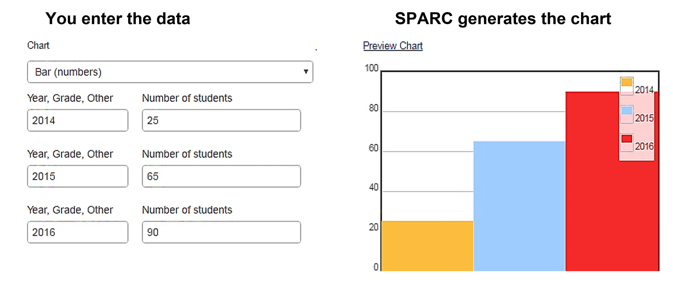
The data is the number of students. The data become the bars in the chart:
Example 2. Career Readiness outcome: Students completed a Career Action Plan.
The comparison labels become the chart legend.
The data are the number of students completing a Career Action Plan.
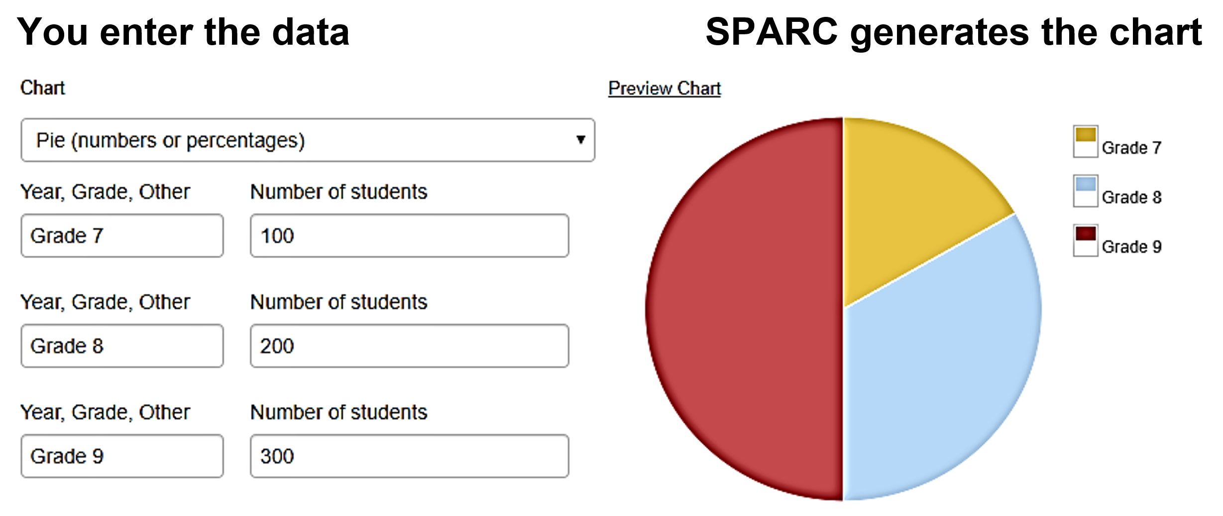
The data become the pie pieces in the chart.
Career & College Readiness Options Helpful Hints, continued
Review the SPARC examples on the SPARC Instructions webpage.
(https://www.sparconline.net/Home/Videos)

3. Twenty-first Century Skills Section
This section provides an opportunity to discuss the ways your students acquire 21st Century Skills.

Required Elements
The narrative describes activities used to develop 21st Century Skills (see examples of 21st Century Skills). Be sure to describe your team’s contribution in achieving the outcomes.
Must include a description to show the connection between SST efforts and the outcome results, use language like “Members of the SST supervised, provided technical assistance, arranged for resource allocation, monitored, taught/led groups, coordinated, contributed, etc.”

Additional Achievements
Use this space to briefly describe up to three additional career and college readiness related achievements not included elsewhere in your SPARC. Here are two examples of Additional Achievements:
- In 2020, every student completed a Career Technical Education (CTE) pathway that helped use reach a 98 percent graduation rate!
- In 2020, our school was awarded a $30,000 grant from Learning through the Arts to support our CTE Media and Arts pathway.

Examples of 21st Century Skills
- Collaboration
- Communication
- Creativity and Innovation
- Critical Thinking and Problem Solving
- Ethics and Legal Responsibilities
- Information and Media Literacy
- Leadership
- Responsibility and Flexibility
- Self-management
- Teamwork
While there is no definitive list of 21st Century Skills, you may wish to refer to the following webpages for more information:
Skills and Qualities for the 21st Century World of Work
https://www.calcareercenter.org/Home/Content?contentID=122
California Standards for Career Ready Practice
http://www.cde.ca.gov/ci/ct/sf/documents/ctescrpflyer.pdf

Helpful Hints
Review the SPARC examples on the SPARC Instructions webpage. (https://www.sparconline.net/Home/Videos)

4. School Site Programs and Community Partnerships
This section asks you to identify your school site programs and community partnerships. These programs and partnerships should reflect an active relationship in funding, organizing, monitoring, collaborating, and/or referrals with your student support system and school.

School Site Programs
School Site Programs are onsite programs and services that support student career and college readiness. Program examples include curricular resources, leadership/personal skills opportunities, student organizations, career center, peer programs, etc.

Required Elements
Must include an introductory narrative explaining the importance of school programs in helping your students become career and college ready. Write your narrative in the textbox.
Must include the program name followed by the resources or elements of the program. List as many programs as space allows, do not use “etc.” See Helpful Hints.

Helpful Hints

School Programs
There are two options for describing your school programs: 1) provide details about the resources used in the program and 2) list the program elements. Below are examples of both options:
Career Exploration: California CareerZone, ASVAB CEP
College Exploration: California CareerZone, KnowHow2GO, CaliforniaColleges.edu
Career Planning: California Career Center, California CareerZone, Big Future
Food for All: Food services, volunteer, and fund-raising opportunities
Citizens 101: Virtual fieldtrips and interviews with prominent citizens
Families in the Loop: Virtual communities, fund-raising, newsletters
If there is not enough space to list all your programs, list the ones with the greatest impact on your students.
School Site Programs and Community Partnerships, continued

Community Partnerships
Community Partnerships are external organizations that provide resources and/or opportunities for your students. Examples include the chamber of commerce, local colleges, businesses, and community-based programs. You may also include parent and/or volunteer organizations.

Required Elements
Must include an introductory narrative explaining the importance of community partnerships in helping your students become career and college ready. Write your narrative in the textbox.
Must include the community partner’s name followed by a brief description of their contributions. List as many partnerships as space allows, do not use “etc.” See Helpful Hints.

Helpful Hints

Community Partnerships
The following Community Partnership examples show the partner’s name followed by a brief description of their contributions to your school:
- Mental Health Center: Mental health services, community resources
- Community Food Bank: Food, internships, supply logistics, and food-science education
- Internet Provider: Reduced or free internet service and technical support
- ACSA Grant: $60,000 grant to print the CDE’s Exploring Career Options workbook for distance learning program

5. Student Support Team (SST)
This section is an opportunity to provide information about who you are as a team and reinforces the themes of professionalism, accountability, and open communication.
Describe your team’s work, identify team members, their qualifications, and list one person as the school site contact for the public.
Your team is comprised of site-based counselors, teachers, teacher librarians, advisers, certificated or classified personnel, volunteers, or other individuals that provide student support services impacting student development of career and college readiness and 21st Century Skills.

Required Elements
Your narrative must include a statement about your school providing an equitable student support system to prepare all students for career and college.
Must also include Information about the team members' memberships in professional organizations or associations. Name the professional organizations or associations.
Identify the team members and their qualifications. Complete the team chart and include each person’s position title, number of years in that position, and qualifications. Follow these criteria:
A minimum of four service areas. Service areas may include school counselor, nurse, psychologist, social worker, classified staff, teacher, administrator, etc.
Qualifications include academic degrees, credentials, specialized training, school district in-service/workshop completion or certification, college credits, or college coursework. Use the initialisms provided in the following Helpful Hints for professional qualifications.
If your SST has more members than will fit on the chart, be sure to list all team members in the Approval section.
Provide the name, telephone number, and email address of a school site contact who can answer questions for volunteers and community organizations that may be interested in providing programs or services to your school.

Helpful Hints
Use the following initialisms for professional qualifications:
AA or AS: Associate of Arts or Associate of Science
ASC: Administrative Services Credential
BA or BS: Bachelor of Arts or Bachelor of Science
CRSC: Clinical Rehabilitative Services Credential
EdD: Doctor of Education
MA or MS: Master of Arts or Master of Science
MFT: Marriage and Family Therapist
MSW: Master of Social Work
PPS: Pupil Personnel Services Credential
PhD: Doctor of Philosophy
RN: Registered Nurse
SLPSC: Speech-Language Pathology Services Credential
SNSC: School Nurse Services Credential
TC: Teaching Credential
TLSC: Teacher Librarian Services Credential
Review the SPARC examples posted on the SPARC Instructions webpage. (https://www.sparconline.net/Home/Videos)

6. Approval Section
In this section, you will enter the information needed to submit your SPARC. You will list the people who participated in creating your SPARC.

Submit Your SPARC
Include the name, telephone number, and email address of the person submitting your SPARC.
Use the SPARC Required Elements Checklist (below) to confirm your SPARC has the required information. Incomplete SPARCs are not reviewed.
Select the “Submit for Review” button.

7. Recognition
SPARCs that pass the official review process will be stamped with the SPARC Seal, the school's name will be listed on the SPARC website, and the SPARC will be posted on the California Career Center’s SPARC webpage. (https://www.calcareercenter.org/sparc)
An email will be sent to the person who submitted your SPARC after April 15 notifying you of your SPARC’s status.
Use your SPARC to publicize your successes. For example:
School Board, faculty and community presentations
LCAP, WASC, or CCR documentation
School and/or district website posting
Parent and/or guardian information
If you are making an important presentation before April 15 and plan to use your SPARC, contact the California Career Resource Network (calcrn@cde.ca.gov) or call 916-323-6544 to ask if your SPARC can be approved before your presentation.

Support Personnel Accountability Report Card
Template Instructions
Use the Template to draft your SPARC narratives. Distribute your draft to your team and incorporate their feedback. Using the template:
- Ensures your content will not be lost if there is an online malfunction
- Keeps your narratives within the character limits
- Saves time by letting you work offline
- Makes it easy to share content with team members
- Makes it easy to see and correct typos and grammatical errors
Once your content is finalized, copy and paste it into the corresponding sections in your SPARC Online app.

Helpful Hints
Compare your narratives to the SPARC Required Elements Checklist to be sure you are including each required element.
Have at least two people proofread your SPARC. SPARCs with errors are not reviewed.
When you copy and paste your text into the SPARC Online app, do not copy the Template headings.

Character Limitations
The character count limitations are listed on the Template. There are two ways you can check your character count:
- Copy your text from your template and paste it into the SPARC Online. If the content fits, great! If not, you need to shorten it.
- Use your word processing software to count your characters. This is how Microsoft Word character count works:
- Highlight the text you want to count.
- Select the “Review” tab from your top navigation bar.
- Select “Word Count”.
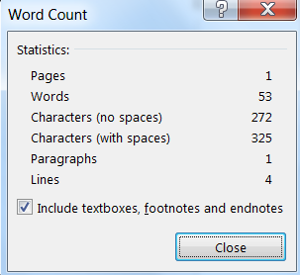
- You will see the Word Count popup window:
  - Use the “Characters (with spaces)” count. Other word processing software likely have a similar process.

Support Personnel Accountability Report Card
Template

School Name

Writer 1 Date Note

Writer 2 Date Note

Writer 3 Date Note

Writer 4 Date Note

Principal’s Message (1,287 character limit)
Type your narrative

Student Outcome Introductory Narrative (474 character limit)
Type your narrative

Career Readiness Narrative (832 character limit)
Type your narrative

College Readiness Narrative (832 character limit)
Type your narrative

21st Century Skills Narrative (832 character limit)
Type your narrative

School Site Programs and Partnerships Narrative (729 character limit)
Type your narrative

Student Support Team Narrative (1,050 character limit)
Type your narrative

Support Personnel Accountability Report Card

Required Elements Checklist
Principal’s Message | Check
Must include a statement about the Student Support Team’s (SST) efforts to support all students becoming career and college ready.
Includes a statement on making/keeping your school environment safe with a climate conducive to learning.
Includes two career and college ready goals you hope to achieve next year.
Includes a statement regarding the alignment of your SPARC to your Local Control Accountability Plan or Single Plan for Student Achievement.
Career and College Readiness Student Outcomes
Introductory paragraph includes a statement describing the importance of student outcomes in general and references the two outcomes you selected in the career and college readiness categories.
One Career Readiness and one College Readiness outcome is selected.
Each outcome has a narrative which describes the outcome selected. Data is included in the narrative and clearly describes the chart.
The SST contribution for achieving these outcomes is clearly described.
21st Century Skills and Additional Achievements
The narrative describes 21st Century Skill outcomes. The SST contribution for achieving these outcomes is clearly described.
Up to three additional career and college readiness achievements are noted.
School Site Programs and Community Partnerships
Includes a narrative explaining the importance of career and college programs and community partnerships at your school.
Includes the program name followed by the resources/elements of the program.
Includes the community partner’s name followed by a brief description of their contribution(s) to your school.
Uses consistent capitalization and punctuation. Does not use “etc.”
Student Support Team
Includes a statement about your school providing an equitable student support system to prepare all students for career and college.
Includes information about the team members' memberships in professional organizations or associations. Organization and association names are listed.
The team chart includes each person’s position title, number of years in that position, and qualifications. Follow these criteria:
A minimum of four service areas must be included.
Qualifications are listed for every team member in the chart.
Includes the school contact name, telephone number, and email address of the contact person the public can call or email for more information about your programs.

