Support Personnel Accountability Report Card
(SPARC) Template
Use this template to write a draft of your SPARC content. The template:
      - Saves you time because you won’t have to go online to work on your SPARC
- Makes it easy to share content with multiple team members at the same time
- Makes it easy to incorporate a variety of changes into one final draft
When your team is satisfied with the content, copy and paste your narratives into the corresponding section in your SPARC Online account.

Student Outcome Narratives
You must select your student outcomes before you can write your introductory student outcome narrative. After you select your outcomes, gather your data and use it to write your narrative.
The outcome data you use to create your charts must be discussed in your career and college narratives. See the SPARC examples in the Instructions document. They are also posted on the Instructions webpage.

Space Limitations
Each narrative textbox has a limited number of available characters.
- You can check your character count by copying your text from your template and pasting it into the SPARC Online textbox to see if it fits.
- You can also check your character count with Microsoft Word using these steps:
  - Highlight the text you want to count.
  - Select “Review” from your top navigation bar.
  - Select “Word Count”.
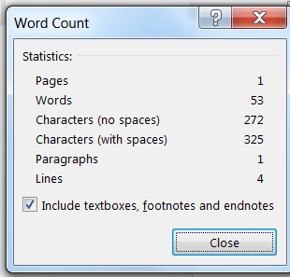
  - You will see a popup window that looks like this:
  - The “Characters (with spaces)” shows your count. Other word processing software likely follows a similar process.
Support Personnel Accountability
Report Card Template

School Name

Writer Date
Reviewer Date

Principal’s Message (1,287 character limit)
Type your narrative here

Student Outcome Introductory Narrative (474 character limit)
Type your narrative here

Career Readiness Narrative (832 character limit)
Type your narrative here

College Readiness Narrative (832 character limit)
Type your narrative here

21st Century Skills Narrative (832 character limit)
Type your narrative here

Programs and Partnerships Narrative (729 character limit)
Type your narrative here

Student Support Team Narrative (1,050 character limit)
Type your narrative here

